19

A MACROECONOMIC THEORY OF THE OPEN ECONOMY

WHAT’S NEW IN THE SEVENTH EDITION:

A new In the News box on “Is a Strong Currency Always in a Nation's Interest?” has been added.

LEARNING OBJECTIVES:

By the end of this chapter, students should understand:

➢ how to build a model to explain an open economy’s trade balance and exchange rate.

➢ how to use the model to analyze the effects of government budget deficits.

➢ how to use the model to analyze the macroeconomic effects of trade policies.

➢ how to use the model to analyze political instability and capital flight.

CONTEXT AND PURPOSE:

The purpose of Chapter 19 is to establish the interdependence of a number of economic variables in an open economy. In particular, Chapter 19 demonstrates the relationships between the prices and quantities in the market for loanable funds and the prices and quantities in the market for foreign-currency exchange. Using these markets, we can analyze the impact of a variety of government policies on an economy’s exchange rate and trade balance.

KEY POINTS:

• Two markets are central to the macroeconomics of open economies: the market for loanable funds and the market for foreign-currency exchange. In the market for loanable funds, the real interest rate adjusts to balance the supply of loanable funds (from national saving) and the demand for loanable funds (for domestic investment and net capital outflow). In the market for foreign-currency exchange, the real exchange rate adjusts to balance the supply of dollars (from net capital outflow) and the demand for dollars (for net exports). Because net capital outflow is part of the demand for loanable funds and because it provides the supply of dollars for foreign-currency exchange, it is the variable that connects these two markets.

• A policy that reduces national saving, such as a government budget deficit, reduces the supply of loanable funds and drives up the interest rate. The higher interest rate reduces net capital outflow, which reduces the supply of dollars in the market for foreign-currency exchange. The dollar appreciates, and net exports fall.

• Although restrictive trade policies, such as tariffs or quotas on imports, are sometimes advocated as a way to alter the trade balance, they do not necessarily have that effect. A trade restriction increases net exports for a given exchange rate and, therefore, increases the demand for dollars in the market for foreign-currency exchange. As a result, the dollar appreciates in value, making domestic goods more expensive relative to foreign goods. This appreciation offsets the initial impact of the trade restriction on net exports.

• When investors change their attitudes about holding assets of a country, the ramifications for the country’s economy can be profound. In particular, political instability can lead to capital flight, which tends to increase interest rates and cause the currency to depreciate.

CHAPTER OUTLINE:

I. Supply and Demand for Loanable Funds and for Foreign-Currency Exchange

A. The Market for Loanable Funds

1. Whenever a nation saves a dollar of income, it can use that dollar to finance the purchase of domestic capital or to finance the purchase of an asset abroad.

2. The supply of loanable funds comes from national saving.

3. The demand for loanable funds comes from domestic investment and net capital outflow.

a. Because net capital outflow can be positive or negative, it can either add to or subtract from the demand for loanable funds that arises from domestic investment.

b. When NCO > 0, the country is experiencing a net outflow of capital. When NCO < 0, the country is experiencing a net inflow of capital.

4. The quantity of loanable funds demanded and the quantity of loanable funds supplied depend on the real interest rate.

a. A higher real interest rate encourages people to save and thus raises the quantity of loanable funds supplied.

b. A higher interest rate makes borrowing to finance capital projects more costly, discouraging investment and reducing the quantity of loanable funds demanded.

c. A higher real interest rate in a country will also lower net capital outflow. All else being equal, a higher domestic interest rate implies that purchases of foreign assets by domestic residents will fall and purchases of domestic assets by foreigners will rise.

You may need to write the equation for net capital outflow on the board to explain its relationship with the real interest rate. Point out that when the U.S. real interest rate rises, purchases of foreign assets by domestic residents fall and purchases of U.S. assets by foreigners rise. Thus, net capital outflow is inversely related to the real interest rate.

5. The supply and demand for loanable funds can be shown graphically.

a. The real interest rate is the price of borrowing funds and is therefore on the vertical axis; the quantity of loanable funds is on the horizontal axis.

b. The supply of loanable funds is upward sloping because of the positive relationship between the real interest rate and the quantity of loanable funds supplied.

c. The demand for loanable funds is downward sloping because of the inverse relationship between the real interest rate and the quantity of loanable funds demanded.

Figure 1

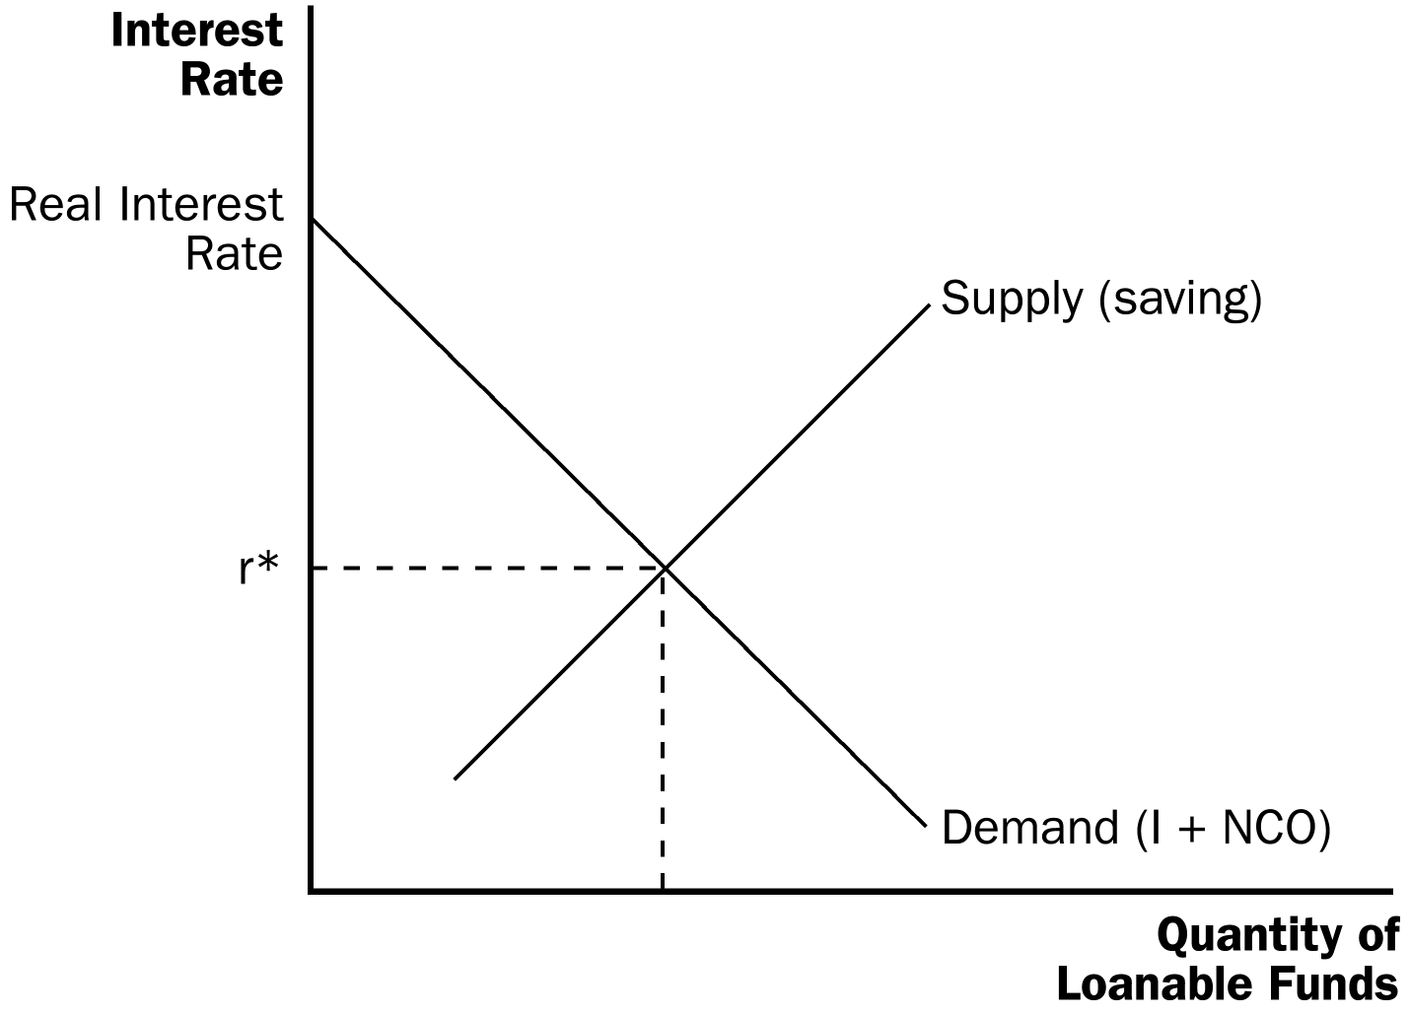
Put “saving” in parentheses next to the supply of loanable funds and “I + NCO ” next to the demand for loanable funds. Encourage students to do the same. These will serve as reminders of the sources of the supply and demand for loanable funds.

6. The interest rate adjusts to bring the supply and demand for loanable funds into balance.

a. If the interest rate were below r*, the quantity of loanable funds demanded would be greater than the quantity of loanable funds supplied. The shortage of loanable funds would lead to upward pressure on the interest rate.

b. If the interest rate were above r*, the quantity of loanable funds demanded would be less than the quantity of loanable funds supplied. The surplus of loanable funds would lead to downward pressure on the interest rate.

7. At the equilibrium interest rate, the amount that people want to save is exactly equal to the desired quantities of domestic investment and net capital outflow.

B. The Market for Foreign-Currency Exchange

1. The imbalance between the purchase and sale of capital assets abroad must be equal to the imbalance between exports and imports of goods and services.

2. Net capital outflow represents the quantity of dollars supplied for the purpose of buying assets abroad.

3. Net exports represent the quantity of dollars demanded for the purpose of buying U.S. net exports of goods and services.

4. The real exchange rate is the price that balances the supply and demand in the market for foreign-currency exchange.

a. When the U.S. real exchange rate appreciates, U.S. goods become more expensive relative to foreign goods, lowering U.S. exports and raising imports. Thus, an increase in the real exchange rate will reduce the quantity of dollars demanded.

b. The key determinant of net capital outflow is the real interest rate. Thus, as the real exchange rate changes, there will be no change in net capital outflow.
Go back to the list of factors that influence net capital outflow (from the previous chapter). Show students that the exchange rate is not there.

5. We can show the market for foreign-currency exchange graphically.

a. The real exchange rate is on the vertical axis; the quantity of dollars exchanged is on the horizontal axis.

b. The demand for dollars will be downward sloping because of the inverse relationship between the real exchange rate and the quantity of dollars demanded.

c. The supply of dollars will be a vertical line because of the fact that changes in the real exchange rate have no influence on the quantity of dollars supplied.

Figure 2

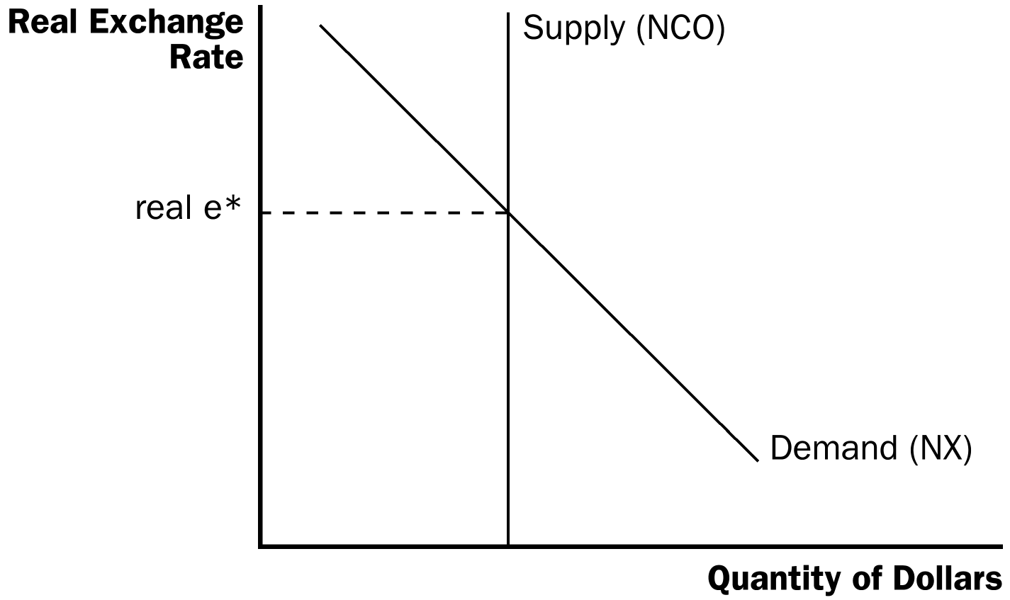

Remind students that net exports determine the demand for dollars by placing “NX ” in parentheses next to the demand curve. Show that net capital outflow determines the supply of dollars by placing “NCO ” in parentheses next to the supply curve.

6. The real exchange rate adjusts to balance the supply and demand for dollars.

a. If the real exchange rate were lower than real e*, the quantity of dollars demanded would be greater than the quantity of dollars supplied and there would be upward pressure on the real exchange rate.

b. If the real exchange rate were higher than real e*, the quantity of dollars demanded would be less than the quantity of dollars supplied and there would be downward pressure on the real exchange rate.

7. At the equilibrium real exchange rate, the demand for dollars to buy net exports exactly balances the supply of dollars to be exchanged into foreign currency to buy assets abroad.

C. FYI: Purchasing-Power Parity as a Special Case

1. Purchasing-power parity suggests that a dollar must buy the same quantity of goods and services in every country. As a result, the real exchange rate is fixed and the nominal exchange rate is determined by the price levels in the two countries.

2. Purchasing-power parity assumes that international trade responds quickly to international price differences.

a. If goods were cheaper in one country than another, they would be exported from the country where they are cheaper and imported into the second country where the prices are higher until the price differential disappears.

b. Because net exports are so responsive to small changes in the real exchange rate, purchasing-power parity implies that the demand for dollars would be horizontal. Thus, purchasing-power parity is simply a special case of the model of the foreign-currency exchange market.

c. However, in practice, foreign and domestic goods are not always perfect substitutes and there are costs that impede trade. Therefore, it is more realistic to draw the demand curve downward sloping.

II. Equilibrium in the Open Economy

A. Net Capital Outflow: The Link between the Two Markets

1. In the market for loanable funds, net capital outflow is one of the sources of demand.

Figure 3

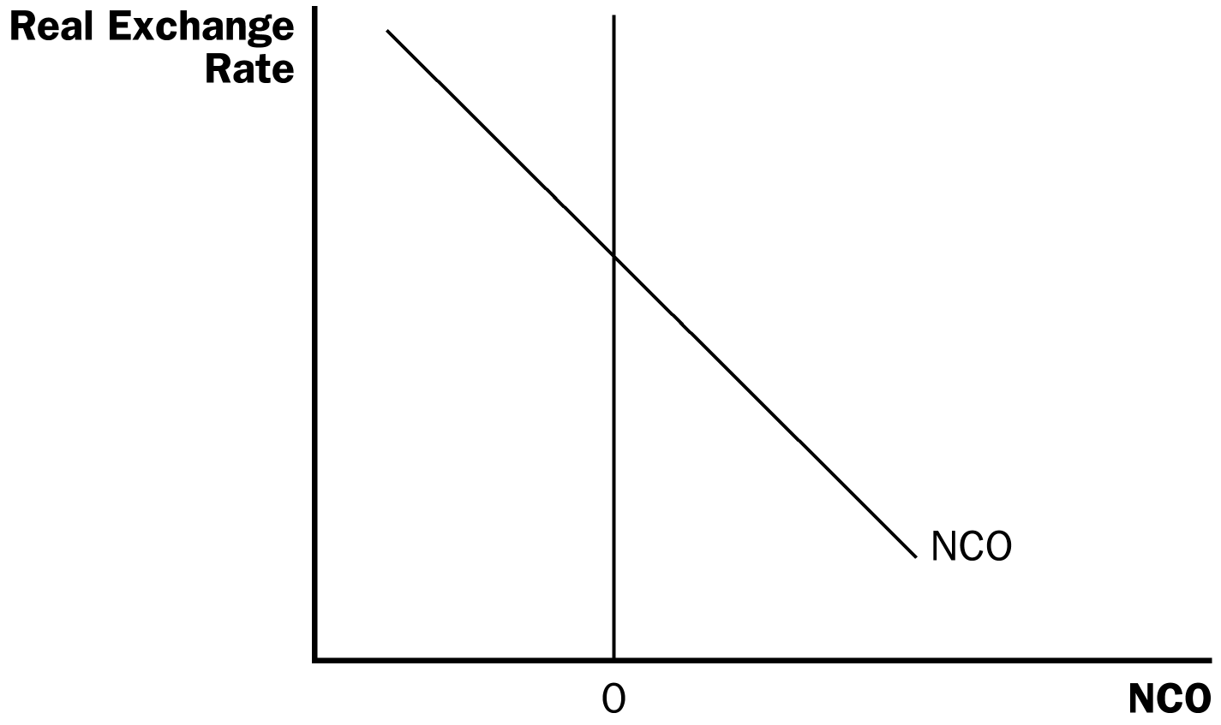

2. In the foreign-currency exchange market, net capital outflow is the source of the supply of dollars.

3. This means that net capital outflow is the variable that links the two markets.

4. The key determinant of net capital outflow is the real interest rate.

5. We can show the relationship between net capital outflow and the real interest rate graphically.

a. When the real interest rate is high, owning domestic assets is more attractive and thus, net capital outflow is low.
Again, you may need to write the equation for net capital outflow on the board to demonstrate the inverse relationship between the real interest rate and net capital outflow.

b. This inverse relationship implies that net capital outflow will be downward sloping.

c. Note that net capital outflow can be positive or negative.

B. Simultaneous Equilibrium in Two Markets
Students will be frightened by the next diagram showing the market for loanable funds and the market for foreign-currency exchange, with the diagram of net capital outflow linking the two. Go through it very slowly. You will likely have to repeat the equilibrium process several times before students understand it.



Figure 4

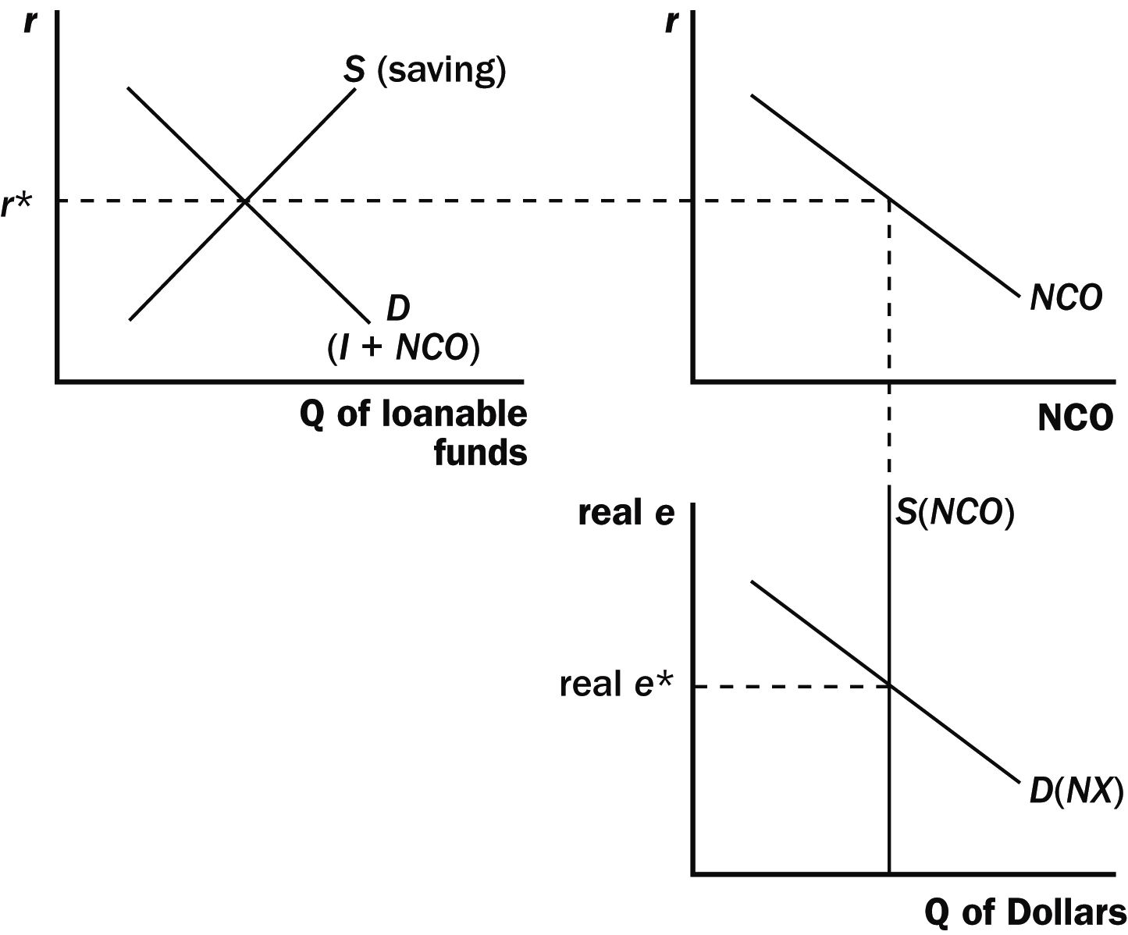

1. The real interest rate is determined in the market for loanable funds.

2. This real interest rate determines the level of net capital outflow.

3. Because net capital outflow must be paid for with foreign currency, the quantity of net capital outflow determines the supply of dollars.

4. The equilibrium real exchange rate brings into balance the quantity of dollars supplied and the quantity of dollars demanded.

5. Thus, the real interest rate and the real exchange rate adjust simultaneously to balance supply and demand in the two markets. As they do so, they determine the levels of national saving, domestic investment, net capital outflow, and net exports.

C. FYI: Disentangling Supply and Demand

1. Sometimes it is a bit arbitrary how we divide things between supply and demand.

2. In the market for loanable funds, our model treats net capital outflow as part of the demand for loanable funds.

a. Investment plus net capital outflow must equal saving (I + NCO = S).

b. Thus, we could say instead that investment is equal to saving minus net capital outflow (I = S – NCO).

3. In the market for foreign-currency exchange, net exports are the source of the demand for dollars and net capital outflow is the source of the supply of dollars.

a. When a U.S. citizen buys an imported good, we treat it as a decrease in the quantity of dollars demanded rather than an increase in the quantity of dollars supplied.

b. When a Japanese citizen buys a U.S. government bond, we treat the transaction as a decline in the quantity of dollars supplied rather than an increase in the quantity of dollars demanded.

III. How Policies and Events Affect an Open Economy
For the next three applications, use the three-step process developed in Chapter 4. First, determine which of the curves have been affected. Second, determine in which direction the curves shift, and finally, use the diagrams to examine how these shifts alter equilibrium in the two markets.

A. Government Budget Deficits

1. A government budget deficit occurs when the government spending exceeds government revenue.

2. Because a government deficit represents negative public saving, it reduces national saving. This leads to a decline in the supply of loanable funds.

3. The real interest rate rises, leading to a decline in both domestic investment and net capital outflow.

4. Because net capital outflow falls, people need less foreign currency to buy foreign assets, and therefore supply fewer dollars in the market for foreign-currency exchange.

5. The real exchange rate rises, making U.S. goods more expensive relative to foreign goods. Exports will fall, imports will rise, and net exports will fall.

6. In an open economy, government budget deficits raise real interest rates, crowd out domestic investment, cause the currency to appreciate, and push the trade balance toward deficit.

7. Because they are so closely related, the budget deficit and the trade deficit are often called the twin deficits. Note that because many other factors affect the trade deficit, these “twins” are not identical.

Figure 5
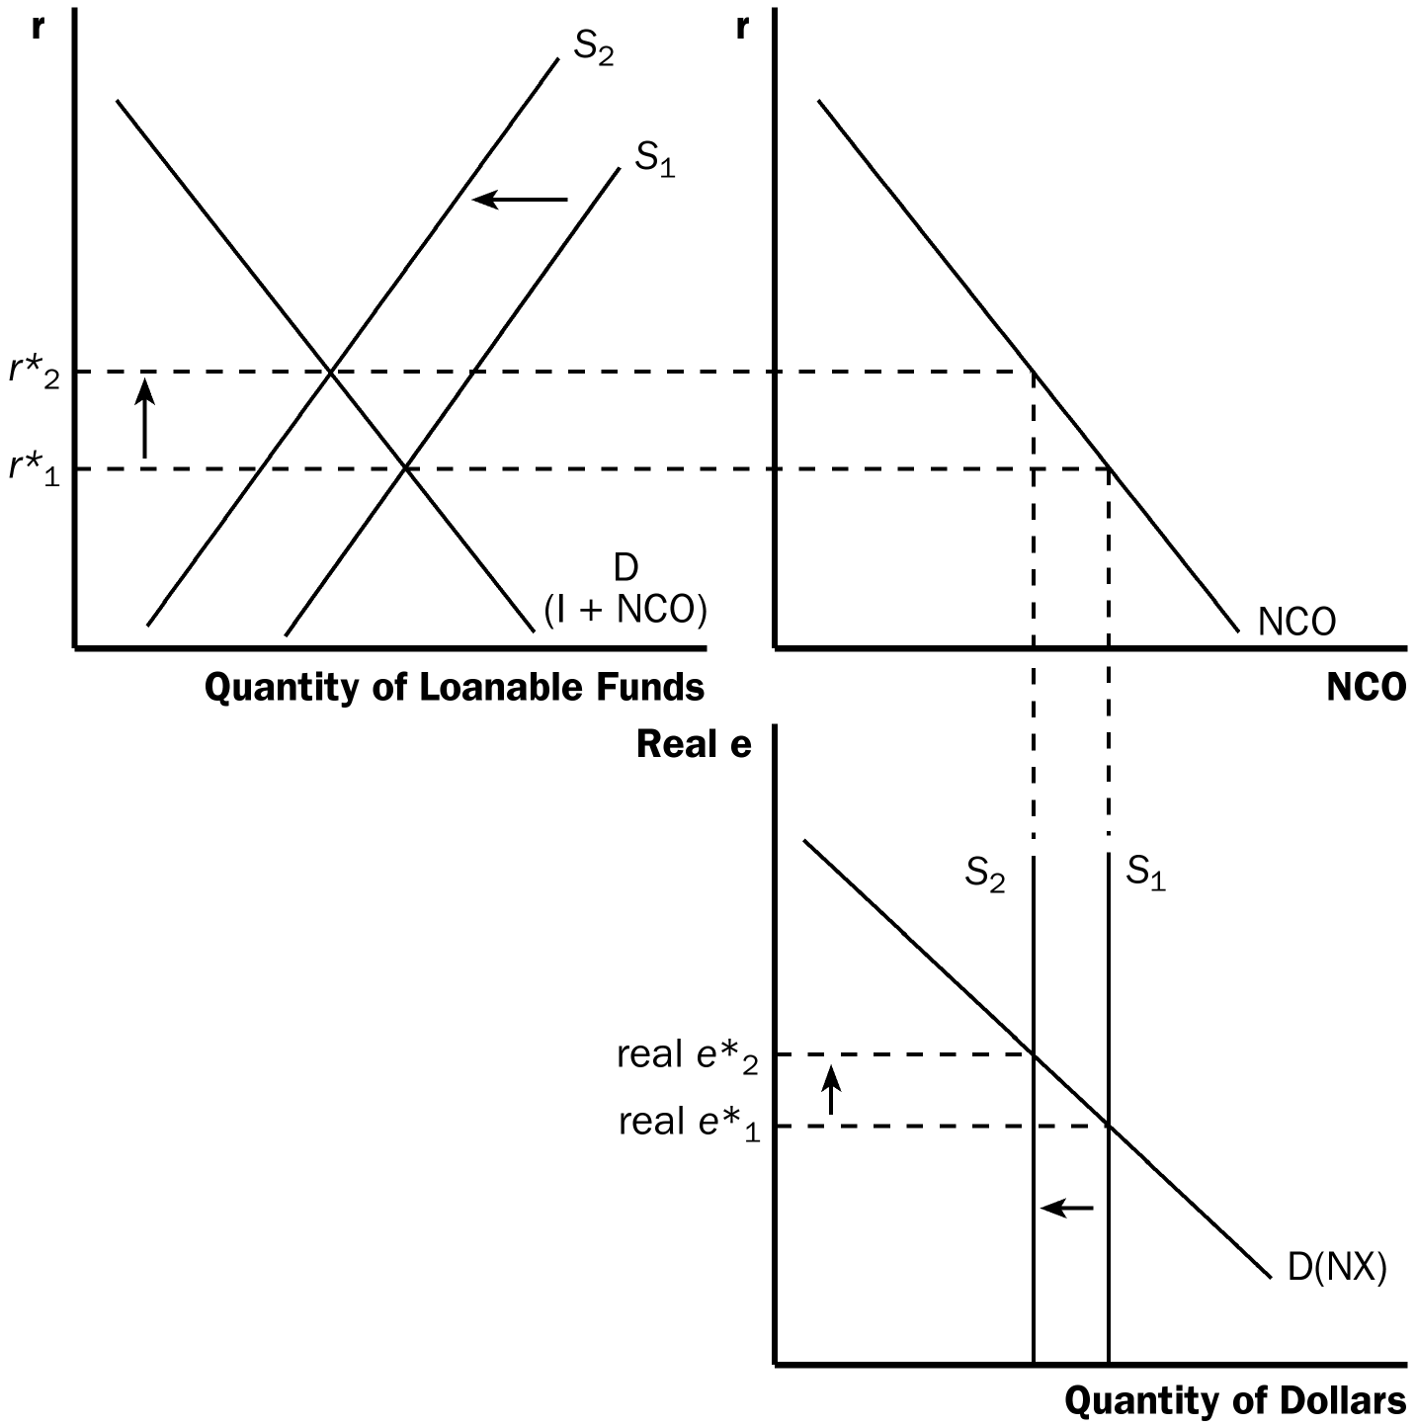
Now would be a good time to discuss the debate in Chapter 23 concerning whether the federal government should balance the budget.

B. Trade Policy

1. Definition of trade policy: a government policy that directly influences the quantity of goods and services that a country imports or exports.

2. Two common types of trade policies are tariffs (taxes on imported goods) and import quotas (limits on the quantity of goods produced abroad that can be sold domestically).

3. Example: The U.S. government imposes a quota on the number of cars imported from Japan.

4. Note that the quota will have no effect on the market for loanable funds. Thus, the real interest rate will be unaffected.

5. The quota will lower imports and thus increase net exports. Because net exports are the source of demand for dollars in the market for foreign-currency exchange, the demand for dollars will increase.

6. The real exchange rate will rise, making U.S. goods relatively more expensive than foreign goods. Exports will fall, imports will rise, and net exports will fall.

7. In the end, the quota reduces both imports and exports but net exports remain the same.

Figure 6

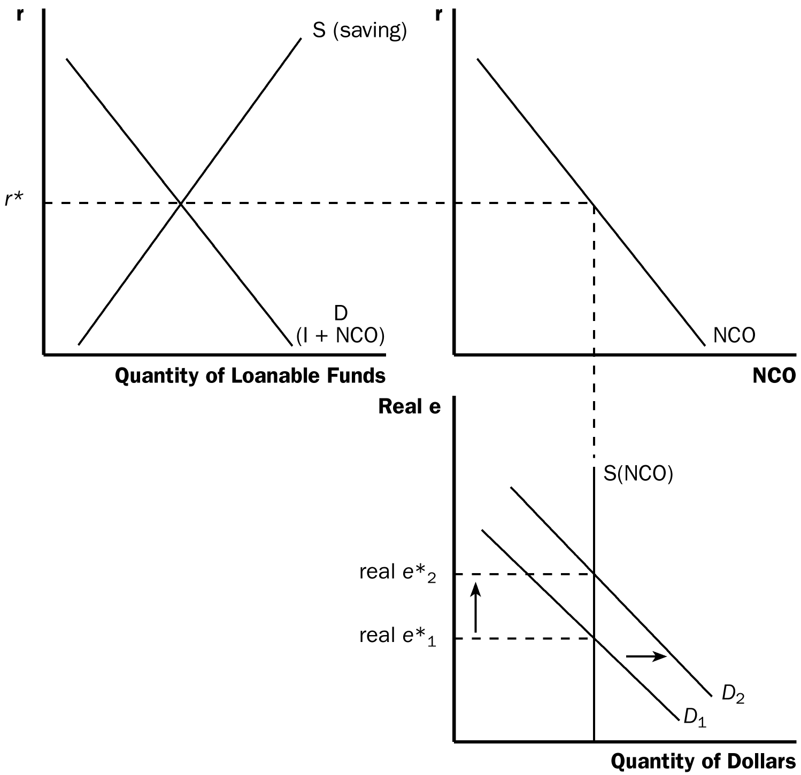

8. Trade policies do not affect the trade balance.

9. Recall that NX = NCO. Also remember that S = I + NCO.

Rewriting, we get:

NCO = S – I.

Substituting for NCO, we get:

NX = S – I.

10. Because trade policies do not affect national saving or domestic investment, they cannot affect net exports.

11. Trade policies do have effects on specific firms, industries, and countries. But these effects are more microeconomic than macroeconomic.

C. Political Instability and Capital Flight

1. Definition of capital flight: a large and sudden reduction in the demand for assets located in a country.

2. Capital flight often occurs because investors feel that the country is unstable, due to either economic or political problems.

3. Example: Investors around the world observe political problems in Mexico and begin selling Mexican assets and buying assets from other countries that are viewed as safe.

4. Mexican net capital outflow will rise because investors are selling Mexican assets and purchasing assets from other countries.

a. Because net capital outflow determines the supply of pesos, the supply of pesos increases.

b. Because net capital outflow is also a part of the demand for loanable funds, the demand for loanable funds rises.

5. The increased demand for loanable funds causes the equilibrium real interest rate to rise.

6. The increased supply of pesos lowers the equilibrium real exchange rate.

7. Thus, capital flight from Mexico increases Mexican interest rates and decreases the value of the Mexican peso in the market for foreign-currency exchange.

8. Capital flight in Mexico will also affect other countries. If the capital flows out of Mexico and into the United States, it has the opposite effect on the U.S. economy.

9. In 1997, several Asian countries experienced capital flight. A similar experience occurred in Russia in 1998 and Argentina in 2002.

Figure 7

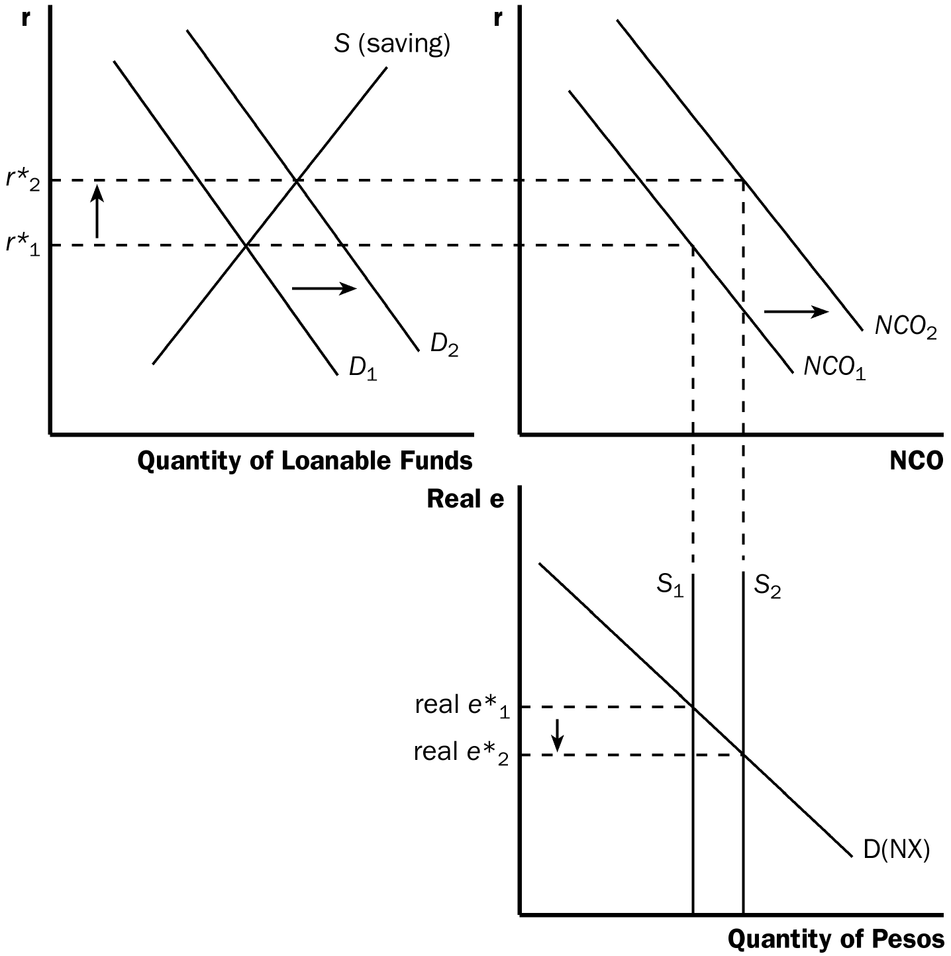

ALTERNATIVE CLASSROOM EXAMPLE:
Suppose that investors feel very confident about the prospects for investment in Brazilian assets.

In this case (from the perspective of Brazil):

1. The demand for loanable funds will shift left because NCO decreases.
2. The NCO curve will also shift left.
3. The real interest rate in Brazil will fall.
4. The supply of reals (the “real” is the currency of Brazil) will shift left.
5. The real exchange rate will rise.
6. Brazilian net exports will fall.

10. Case Study: Capital Flows from China

a. What happens if a country’s government encourages capital to flow to other countries?

b. It leads to a weaker currency and a trade surplus.

c. In recent years, this has been the case with China as its government has tried to depress its currency.

Activity 1—Open Economy Article

Type: Take-home assignment
Topics: Open-economy macroeconomics
Class limitations: Works in any class

Purpose
This assignment helps students apply the open-economy macro model to world events.

Instructions
This model is often confusing to students. This assignment has them work through an example of real-world events that relate to international macroeconomics. Students may need some direction in finding appropriate topics such as interest rate changes, changes in net capital outflow, or changes in net exports.

Assignment
1. Find an article in a recent newspaper or magazine illustrating a change that will affect net capital outflow or net exports.
2. Explain how and why net capital outflow or net exports would shift.
3. Use the three market open-economy model (the market for loanable funds, net capital outflow, and the market for foreign-currency exchange) to analyze this change.
4. Graph the equilibrium real interest rate, level of net capital outflow, and real exchange rate before the change. Then show how the change will affect these variables.
5. Turn in a copy of the article along with your explanation.

11. In the News: Is a Strong Currency Always in a Nation's Interest

a. Politicians assert that the U.S. favors a strong dollar.

b. This article from The New York Times discusses when a strong or weak currency can be beneficial.

SOLUTIONS TO TEXT PROBLEMS:

Quick Quizzes

1. The supply of loanable funds comes from national saving. The demand for loanable funds comes from domestic investment and net capital outflow. The supply in the market for foreign-currency exchange comes from net capital outflow. The demand in the market for foreign-currency exchange comes from net exports.

2. The two markets in the model of the open economy are the market for loanable funds and the market for foreign-currency exchange. These markets determine two relative prices: (1) the market for loanable funds determines the real interest rate and (2) the market for foreign-currency exchange determines the real exchange rate.

3. If Americans decided to spend a smaller fraction of their incomes, the increase in saving would shift the supply curve for loanable funds to the right, as shown in Figure 1. The decline in the real interest rate increases net capital outflow and shifts the supply of dollars to the right in the market for foreign-currency exchange. The result is a decline in the real exchange rate. Since the real interest rate is lower, domestic investment increases. Since the real exchange rate declines, net exports increase and the trade balance moves toward surplus. Overall, saving and domestic investment increase, the real interest rate and real exchange rate decrease, and the trade balance moves toward surplus.

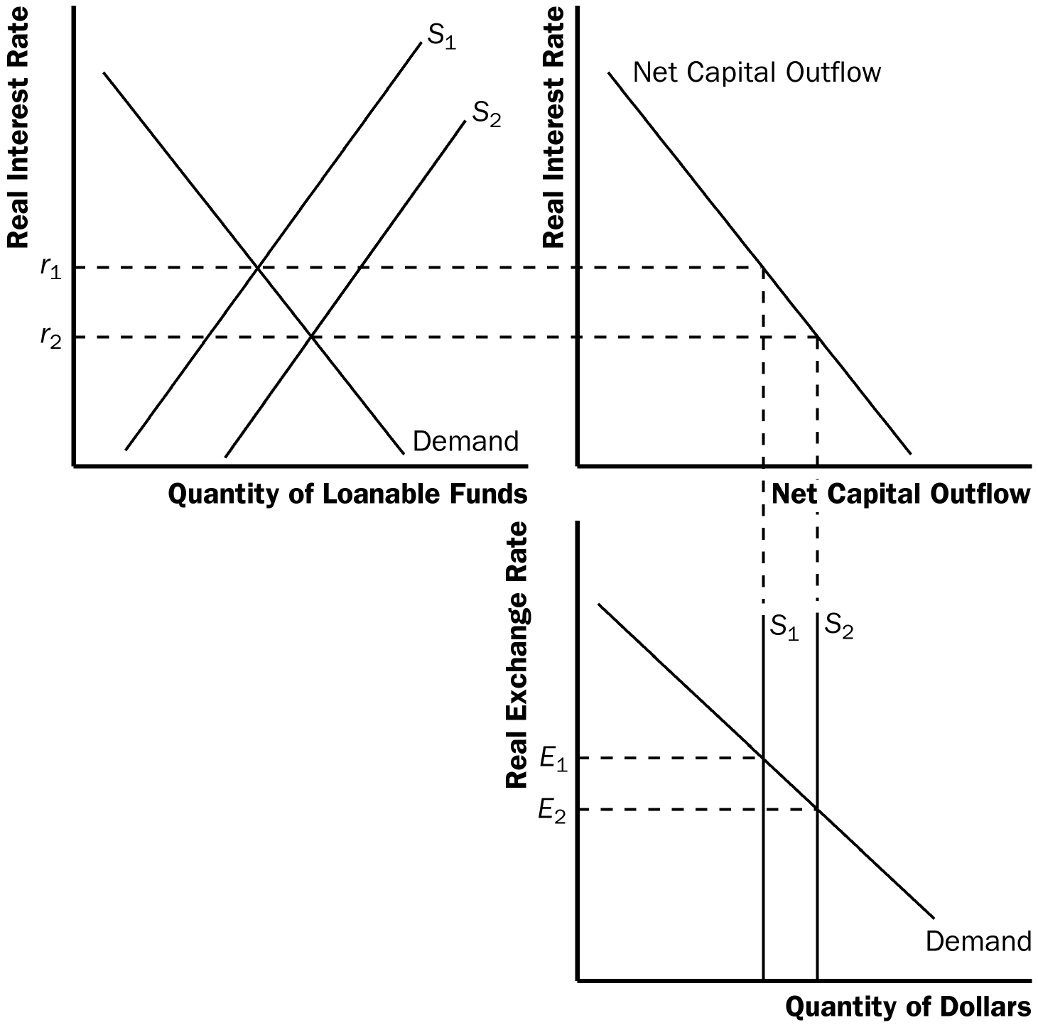

Figure 1

Questions for Review

1. The supply of loanable funds comes from national saving; the demand for loanable funds comes from domestic investment and net capital outflow. The supply of dollars in the market for foreign exchange comes from net capital outflow; the demand for dollars in the market for foreign exchange comes from net exports. The link between the two markets is net capital outflow.

2. Government budget deficits and trade deficits are sometimes called the twin deficits because a government budget deficit often leads to a trade deficit. The government budget deficit leads to reduced national saving, causing the interest rate to increase, and reducing net capital outflow. The decline in net capital outflow reduces the supply of dollars, raising the real exchange rate. Thus, the trade balance will move toward deficit.

3. If a union of textile workers encourages people to buy only American-made clothes, imports would be reduced, so net exports would increase for any given real exchange rate. This would cause the demand curve in the market for foreign exchange to shift to the right, as shown in Figure 2. The result is a rise in the real exchange rate, but no effect on the trade balance. The textile industry would import less, but other industries, such as the auto industry, would import more because of the higher real exchange rate.

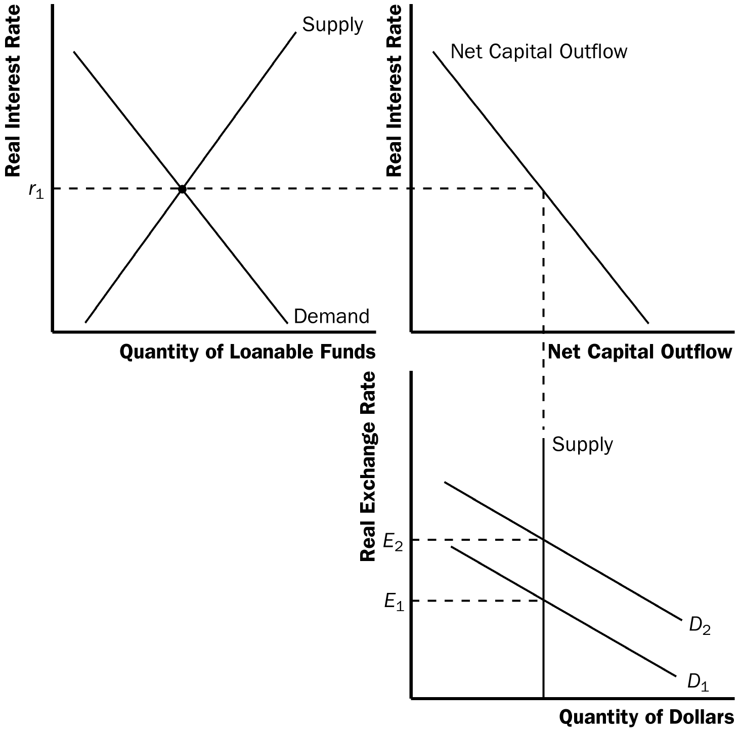

Figure 2

4. Capital flight is a large and sudden movement of funds out of a country. Capital flight causes the interest rate to increase and the exchange rate to depreciate.

Quick Check Multiple Choice

1. c

2. b

3. b

4. a

5. d

6. a

Problems and Applications

1. Japan generally runs a trade surplus because the Japanese saving rate is high relative to Japanese domestic investment. The result is high net capital outflow, which is matched by high net exports, resulting in a trade surplus. The other possibilities (high foreign demand for Japanese goods, low Japanese demand for foreign goods, and structural barriers against imports into Japan) would affect the real exchange rate, but not the trade surplus.

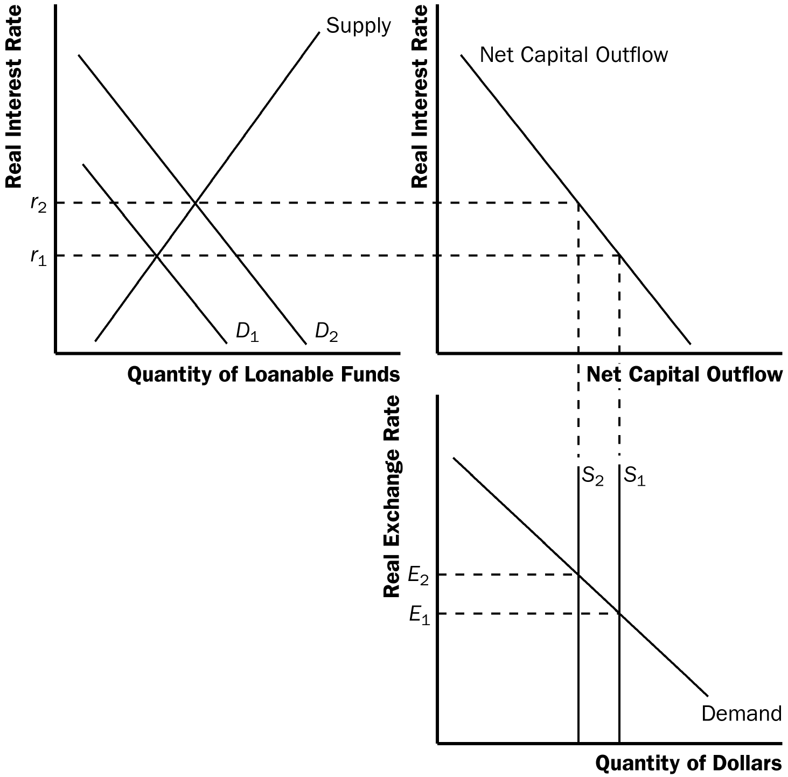
Figure 3

2. a. If Congress passes an investment tax credit, it subsidizes domestic investment. The desire to increase domestic investment leads firms to borrow more, increasing the demand for loanable funds, as shown in Figure 3. This raises the real interest rate, thus reducing net capital outflow. The decline in net capital outflow reduces the supply of dollars in the market for foreign exchange, raising the real exchange rate. The trade balance moves toward deficit, because net capital outflow, hence net exports, is lower. The higher real interest rate also increases the quantity of national saving. In summary, saving increases, domestic investment increases, net capital outflow declines, the real interest rate increases, the real exchange rate increases, and the trade balance moves toward deficit.

b. A rise in the real exchange rate reduces exports.

3. a. A decline in the quality of U.S. goods at a given real exchange rate would reduce net exports, reducing the demand for dollars, thus shifting the demand curve for dollars to the left in the market for foreign exchange, as shown in Figure 4.

b. The shift to the left of the demand curve for dollars leads to a decline in the real exchange rate. Because net capital outflow is unchanged, and net exports equals net capital outflow, there is no change in equilibrium in net exports or the trade balance.

c. The claim in the popular press is incorrect. A change in the quality of U.S. goods cannot lead to a rise in the trade deficit. The decline in the real exchange rate means that we get fewer foreign goods in exchange for our goods, so our standard of living may decline.

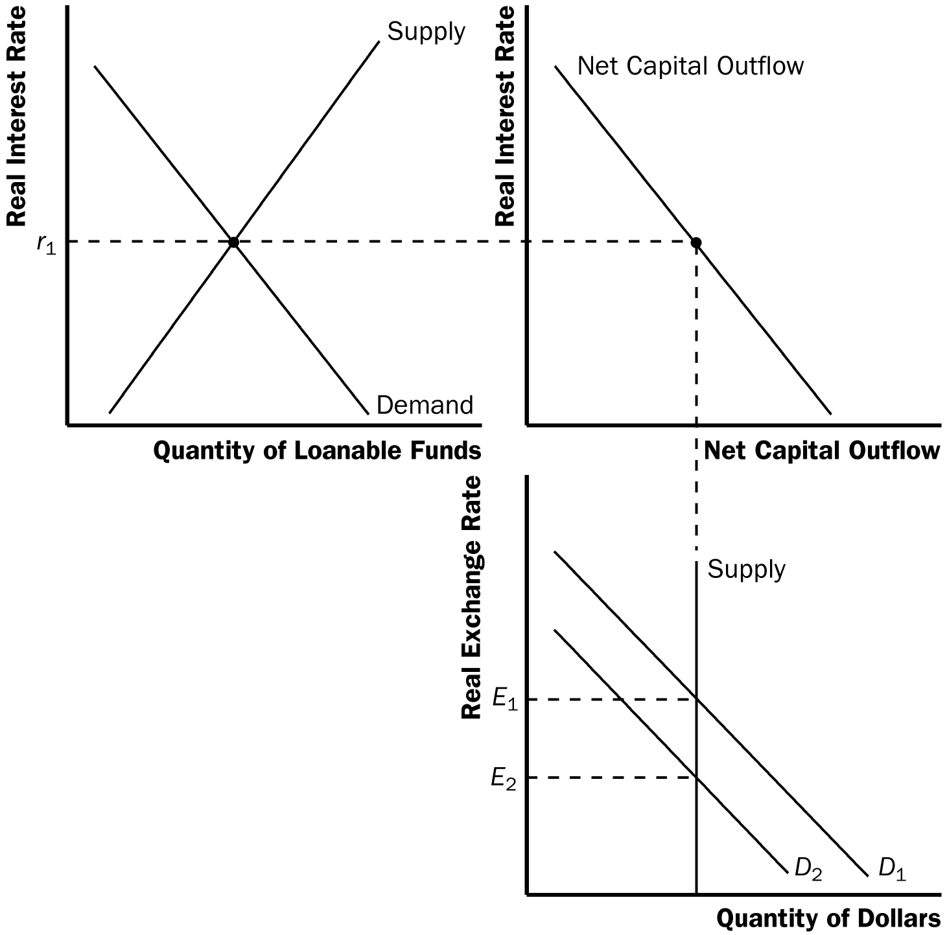

Figure 4

4. A reduction in restrictions of imports would reduce net exports at any given real exchange rate, thus shifting the demand curve for dollars to the left. The shift of the demand curve for dollars leads to a decline in the real exchange rate, which increases net exports. Because net capital outflow is unchanged and net exports equals net capital outflow, there is no change in equilibrium in net exports or the trade balance. But both imports and exports rise, so export industries benefit.

5. a. When the French develop a strong taste for California wines, the demand for dollars in the foreign-currency market increases at any given real exchange rate, as shown in Figure 5.

b. The result of the increased demand for dollars is a rise in the real exchange rate.

c. The quantity of net exports is unchanged.

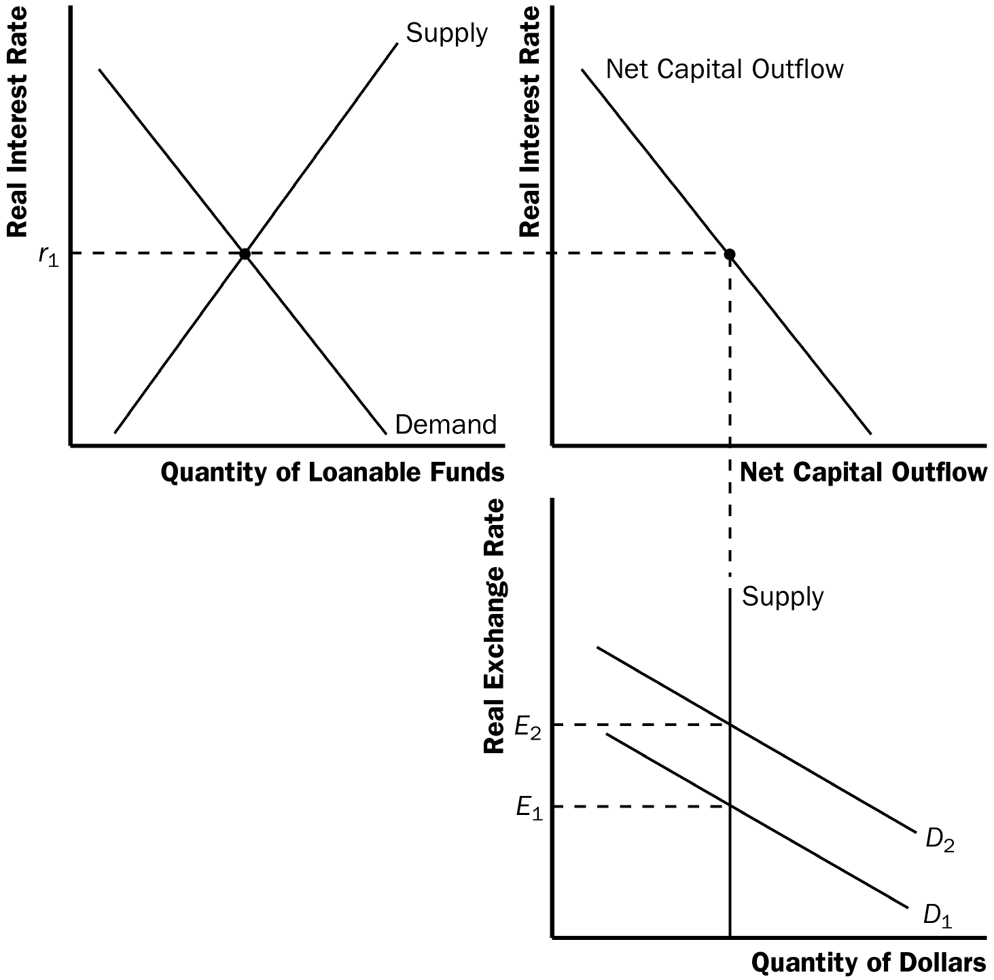

Figure 5

6. An export subsidy increases net exports at any given real exchange rate, causing the demand for dollars in the foreign exchange market to shift to the right as shown in Figure 6. The resulting increase in the real exchange rate increases imports to match the increase in exports generated by the export subsidy. Thus, net exports and the trade deficit are unchanged. The senator is incorrect.

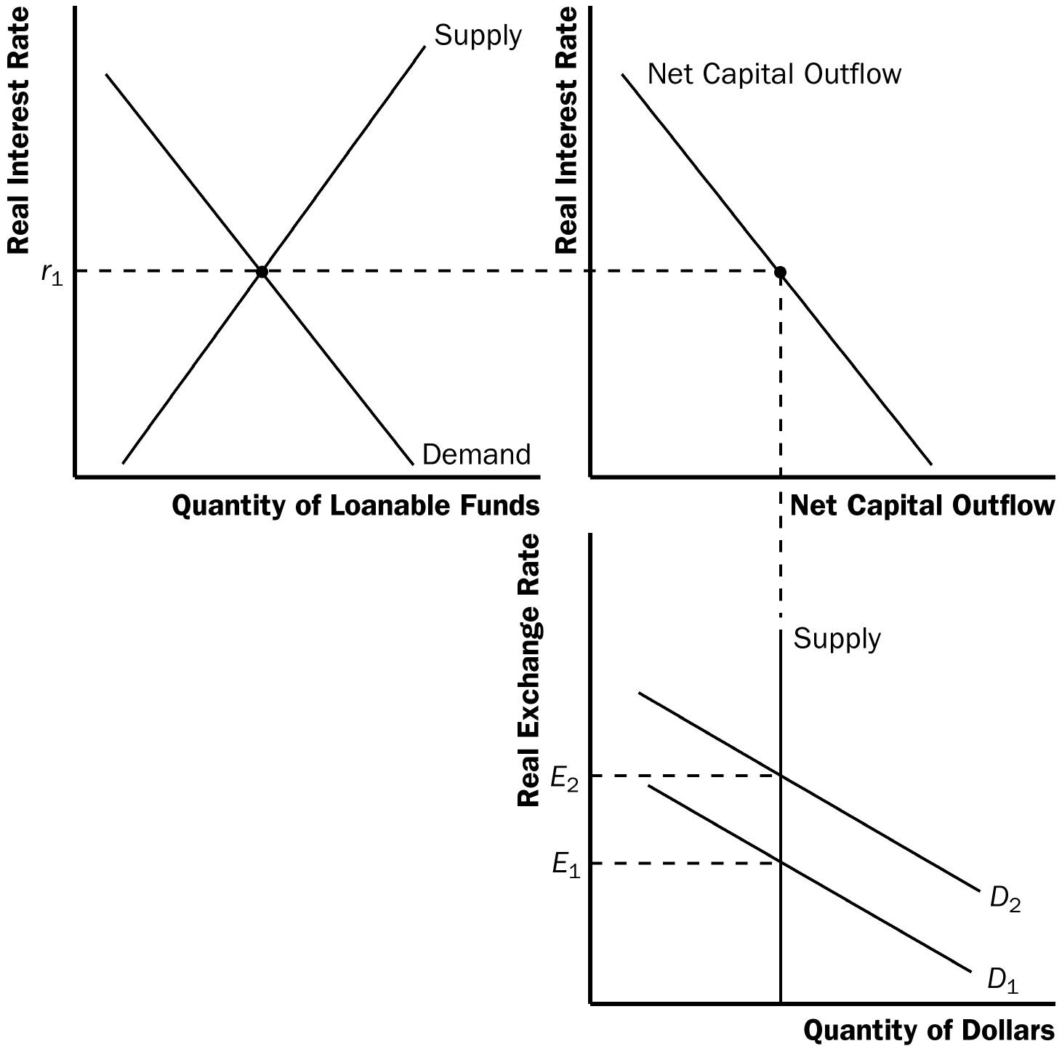

Figure 6

7. An export subsidy increases net exports at any given real exchange rate, causing the demand for dollars in the foreign exchange market to shift to the right as shown in Figure 7. The resulting increase in the real exchange rate increases imports to match the increase in exports generated by the export subsidy. Thus, net exports and the trade deficit are unchanged at this point. The expenditure on the export subsidy, however, increases the fiscal deficit, decreases public saving, causing the supply of loanable funds to shift left. The resulting increase in the real interest rate reduces domestic investment and net capital outflow, decreasing the supply of dollars on the foreign exchange market. The real exchange rate rises again, further increasing imports but decreasing exports. In the end, imports increase, exports could increase or decrease, net exports fall, and the trade balance moves toward deficit.

S₂
r
r
S₁

r*₂
r*₁

NCO
D
(I + NCO)

NCO
Quantity of Loanable Funds

S₁
real e
S₂

real e*₃

real e*₂

real e*₁
D₂

D₁

Quantity of Dollars

Figure 7

8. Higher real interest rates in Europe lead to increased U.S. net capital outflow. Higher net capital outflow leads to higher net exports, because in equilibrium net exports equal net capital outflow (NX = NCO ). Figure 8 shows that the increase in net capital outflow leads to a lower real exchange rate, higher real interest rate, and increased net exports.

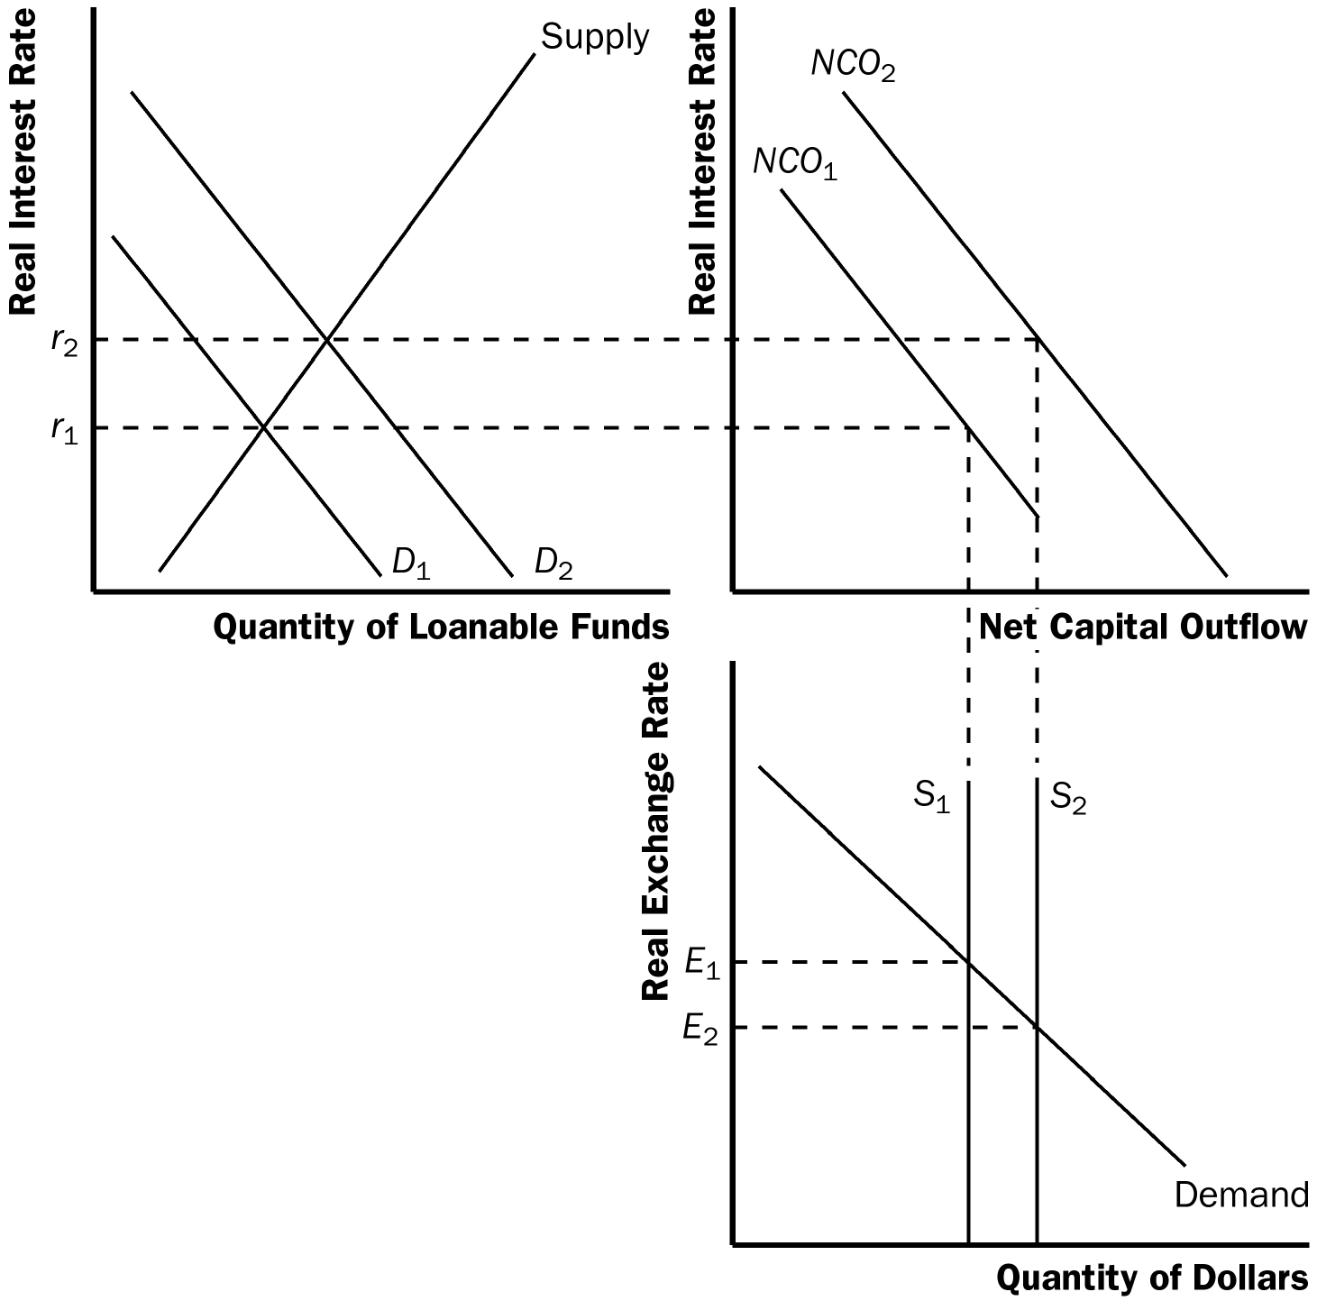

Figure 8

9. a. If the elasticity of U.S. net capital outflow with respect to the real interest rate is very high, the lower real interest rate that occurs because of the increase in private saving will increase net capital outflow a great deal, so U.S. domestic investment will not increase much.

b. Because an increase in private saving reduces the real interest rate, inducing an increase in net capital outflow, the real exchange rate will decline. If the elasticity of U.S. exports with respect to the real exchange rate is very low, it will take a large decline in the real exchange rate to increase U.S. net exports by enough to match the increase in net capital outflow.

